TOMST Raw Graphs (no TNP Processing)

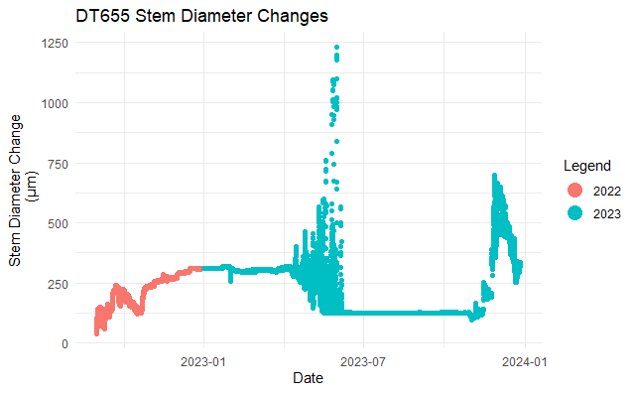

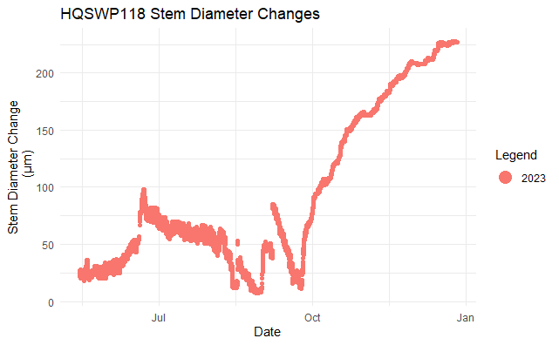

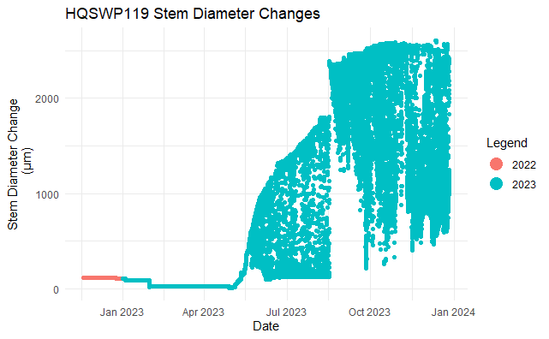

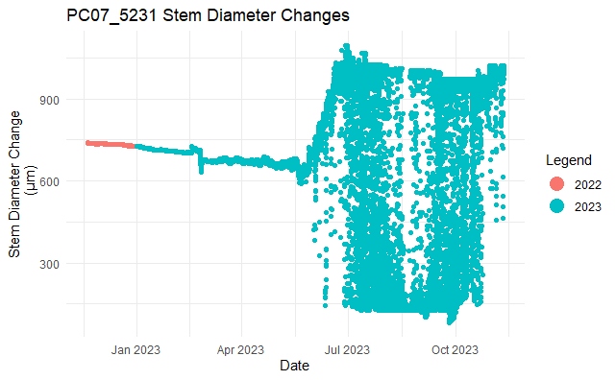

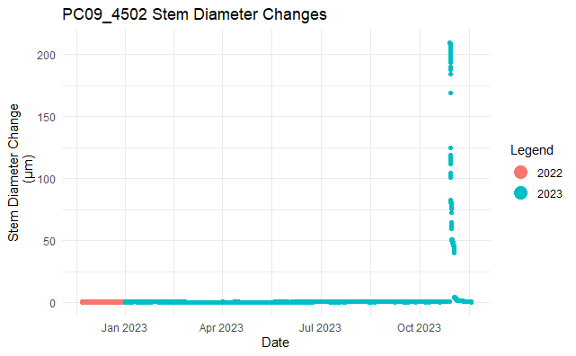

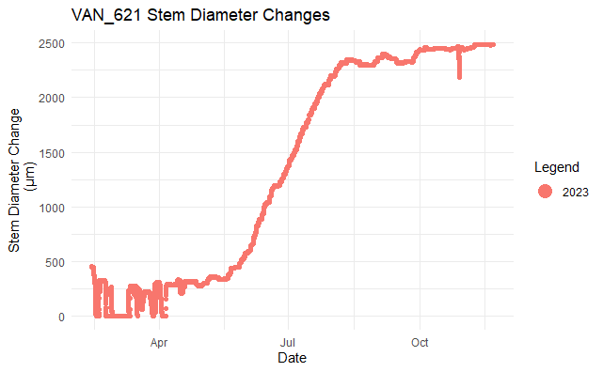

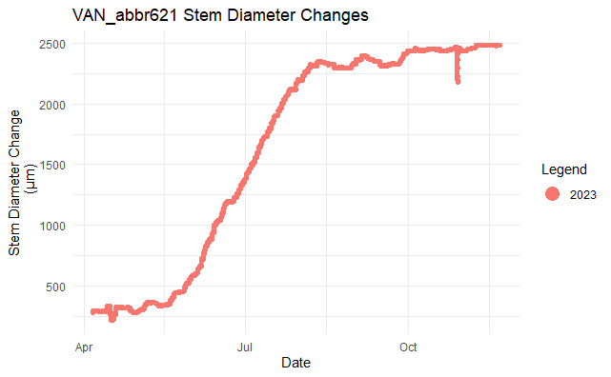

--end--